Lab Evaluation:

Course Name: Object Oriented Programming |  |  |  | Course Code: CMPE 221L
Assignment Type: Lab |  |  |  | Dated: 1-7-2026
Semester: 2rd |  |  |  | Session: 2025
Lab/Project/Assignment #: 8 |  |  |  | CLOs to be covered: CLO1
Lab Title: Inheritance, Constructor Overloading, Method Overriding, and Runtime Polymorphism in Java |  |  |  | Teacher Name: Hafiz Muhammad Mubashar
CLO1 | Implement abstraction and encapsulation to develop reusable classes for objects of real-world problems
Levels (Marks) | Level1 | Level2 | Level3 |  | Level4 | Level5 | Level6
(10)
Total |  |  |  |  |  |  | /10

Rubrics for Current Lab Evaluation
Scale | Marks | Level | Rubric
Excellent | 9-10 | L1 | Submitted all lab tasks, BONUS task, have good understanding.
Very Good | 7-8 | L2 | Submitted the lab tasks but have good understanding
Good | 5-6 | L3 | Submitted the lab tasks but have weak understanding.
Basic | 3-4 | L4 | Submitted the lab tasks but have no understanding.
Barely Acceptable | 1-2 | L5 | Submitted only one lab task.
Not Acceptable | 0 | L6 | Did not attempt

LAB No. 8
Lab Goals/Objectives:

• Getting Started with Java
• Acquiring practice with familiar programming constructs in JAVA

University Of Engineering and Technology, Lahore Computer Engineering Department
Equipment Required: Inteli J IDEA Edition Community, Net Beans with JDK 13 Version, Visual Studio.
Theory/Relevant Material: Write First Java Program
1.Write a Java program to demonstrate constructor overloading, constructor chaining using this(), inheritance using the super keyword, and the use of a copy constructor. Create a measurements class to calculate the area of a square, the perimeter of a rectangle, and the volume of a box using overloaded constructors. Then, create a derived box class that invokes the parent class constructor and displays a message to demonstrate inheritance.

2.Write a Java program to demonstrate inheritance and upcasting in Java. Create a reference of the parent class that points to an object of the child class and another reference of the child class. Explain how a parent class reference can access only the members of the parent class, even when it refers to a child class object.

3.Write a Java program to demonstrate method overriding and runtime polymorphism using inheritance. Create a Parent class containing overloaded methods and a Child class that overrides one of the parent class methods. Instantiate objects of both the parent and child classes, including a parent class reference pointing to a child class object, to illustrate inheritance and polymorphic behavior.

TASK 1:
package INHERITENCE;

class measurements {

float length;
float width;
float height;
float perimeter;
float squareArea;
float boxVolume;

measurements(float side) {
this.length = side;
squareArea = this.length * this.length;
System.out.println("area = " + squareArea);
}

measurements(float length, float width) {
this(1, 2, 3); // Calls the 3-parameter constructor
this.length = length;
this.width = width;
this.perimeter = 2 * (this.length + this.width);
}

private void showPerimeter() { // This method is not inherited
System.out.println("perimeter = " + this.perimeter);
}

private measurements(float length, float width, float height) {
this.length = length;
this.width = width;
this.height = height;
boxVolume = this.height * (this.length * this.width);
System.out.println("volume = " + boxVolume);
}

measurements(measurements obj) {
this.length = obj.length;
this.width = obj.width;
this.height = obj.height;

System.out.println("ITS OVERLOADING");
System.out.println(length + "\n" + width + "\n" + height);
}
}

class box extends measurements {

box() {
super(1, 2);
// super(1,2,3); // Cannot call because it is private
System.out.println("HEY BOX I'M HERE.");
}

void displayBox() {
System.out.println("I AM BOX");
}
}

RESULT:
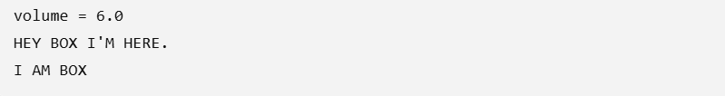

TASK 2:
package INHERITENCE;

public class in {
public static void main(String[] args) {

INHERITENCE.measurements measureRef = new INHERITENCE.box();
INHERITENCE.box actualBox = new INHERITENCE.box();

// measureRef.dis(); // Not allowed because through measureRef
// we can only access the members of measurements.

}
}

RESULT:

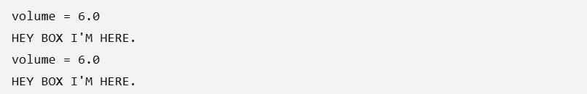

TASK 3:
public class my {
public static void main(String[] args) {

Parent obj1 = new Parent();
Child obj2 = new Child();
Parent obj3 = new Child();

}
}

class Parent {

public void display(int num) {
System.out.println("ALI");
}

private void display(int num1, int num2) {
System.out.println("ALI:" + (num1 * num2));
}

float printValue(float value) {
System.out.println("ALI:" + value);
return 4.0f;
}
}

class Child extends Parent {

@Override
public void display(int num) {
System.out.println("AHMAD");
}

}

RESULT:

NO OUTPUT

CONCLUSION:
These programs demonstrate the core concepts of object-oriented programming in Java, including constructor overloading, constructor chaining, inheritance, method overriding, upcasting, and runtime polymorphism. They illustrate how parent and child classes interact, how constructors are invoked using the this and super keywords, and how overridden methods enable dynamic method dispatch. Together, these programs strengthen the understanding of inheritance hierarchies, object creation, and polymorphic behavior, providing a solid foundation for designing reusable, modular, and efficient Java applications.

